Technological, regulatory and business aspects of LPWAN implementation in IoT

Atanas Godzoski Toni Janevski Aleksandar Risteski

Ss. Cyril and Methodius University, Faculty of Electrical Engineering and Information Technologies
Karpos 2 bb, 1000 Skopje, Republic of Macedonia
atanas.godzoski@gmail.com

Abstract — The Internet of Things (IoT) concept consists of a large number of connected devices placed on a large area and the most suitable communication for this type of implementations are the Low Power Wide Area Networks (LPWANs) which are characterized with low power consumption and high coverage range.
Тhese features of LPWANs are obtained by using digital modulation techniques that produce a sufficiently strong signal to transmit long distances.
For efficient use of the radio spectrum, which from the aspect of telecommunications is not an infinite resource, several regulations have been adopted that define the work of LPWANs.
IoT has an increasing role in everyday life (business, medicine, education, entertainment, etc.) and it is necessary to adjust the characteristics of LPWANs (range, transmission speed, security, number of nodes) in order for IoT applications to be appropriate for the field in which they are implemented.

Keywords — ICT, Internet of Things, IoT, ISM, LoRa, LPWAN, NB-IoT, Sigfox.

Introduction
THE Information and Communication Technology (ICT) rapid development was followed by emerging the new technology concepts and applications in all aspects of human life - business, entertainment, medicine, education and more. One of the new concepts that is more and more used in all life areas is the IoT which in general can describe as a large number of interconnected devices (sensors, actuators, electronic devices etc.) which share data with each other and other devices, execute commands etc, [1-2].
A basic feature of IoT is the connection between the devices (and here when we say connection we usually mean wireless connection) and depending on the specific application, the frequency bands within which the IoT devices operate range from 13.56MHz for contactless payment devices up to 2.4GHz and more for apps that require video streaming and other large data exchanging.
To achieve these characteristics of LPWAN and depending on the specific application, several different types of modulations are used, between which the most commonly used are Narrow Band Modulation and Spread Spectrum Modulation, described in section II.
Although theoretically the radio spectrum is an unlimited resource, in terms of wireless telecommunications and wireless signal transmission, the spectrum has several limiting factors: the lowest frequency at which signals can differ from noise, high frequencies that are dangerous to human health, the signal loss over distance (free space loss) etc. Therefore, from the aspect of telecommunications, the radio spectrum is a limited resource and that is why the countries and international regulators have adopted several rules and restrictions in order to use it with the maximum efficient, which are described in section III.
Modern technology, which includes the IoT concept too, has a crucial use in all aspects of life and its application facilitates and promotes activities in all areas where it is used in terms of efficiency, information processing, economy, etc. Section IV presents the main areas where IoT can be or is applied, with specific application implementations, but also the required features of LPWAN in relation to the area specifics in which the IoT application would be applied, possible shortcomings and necessary improvements and adjustments.

LPWANs modulations and technical overview

LPWANs features overview
The shortest description of the IoT concept is that it is a network of a large number of connected smart devices (sensors, actuators, Systems On a Chip, etc.) that bi-directionally exchange information with higher-level software apps that apps return feedback commands, transmit information for further processing, perform statistical analysis, make decisions, and so on.
The frequency bands within which IoT devices operate range from 13.56MHz for contactless payment devices to 2.4GHz and more for applications that require video streaming and large data exchanging. In which frequency range the IoT communication will be placed depends on the specific application requirements and the devices location and density. An urban area (with many obstacles, concrete structures, etc.) has less effect on the signal operating at low frequency and on the other hand, communication in sub-GHz bands provides both signal security and stability.
The most suitable medium for connecting IoT devices are the LPWANs due to their low power consumption, large coverage and low costs operation and maintenance.
These networks operate in the licensed and unlicensed ISM (Industrial, Scientific and Medicine) SubGHz frequency bands (e.g., 868MHz in Europe, and 915MHz in the U.S.) and the communication range reaches up to 15km in rural areas and up to 5km in urban areas.
Such a large reach and coverage of LPWAN is possible with a new approach to the design of the physical level of communication that provides high sensitivity (e.g., -130dBm) with the limitation - the low transmission speed (from a few hundred to a few thousand bps).

LPWAN modulation techniques
i) Modulation techniques in telecommunications

In telecommunications, the process in which the carrier frequency (carrier) is combined with another signal containing the data to be sent over the channel is called modulation. Each signal has three characteristics that can be modulated: frequency, amplitude and phase. The frequency of a wave defines how often it repeats, the amplitude gives us the strength or power of the waveform, and the phase gives us the state of the waveform with respect to time in a given cycle. The final waveform of the modulated signal is formed by the modulation of the carrier and the data signal.

The three basic types of modulation are:
Frequency modulation: Frequency modulation is used in FM radio, radar, telemetry, music synthesis, etc. Here the signal to be sent is integrated into the carrier by changing its frequency.
Amplitude modulation: AM radio is a common example of using amplitude modulation, by which the data signal is integrated by changing the amplitude of the signal carrier.
Digital modulation: The previous two types of modulation are used for analog signals and are not suitable for the modulation of digital signals represented by a series of 1's and 0's. Amplitude shift keying (ASK), Phase shift keying (PSK) and Frequency shift keying (FSK) are used to modulate digital signals.

ii) LPWAN modulation techniques

The LPWAN technologies have a range of tens of kilometers (rural areas) to a few kilometers (urban areas) and most of the them slow down their modulation rates in order to put more energy in each transmitted bit or symbol so that the receivers are able to decode even the weakest signals without any errors. In general, the receiver sensitivity for LPWAN technologies is around -150dBm.

The two most used modulation techniques in LPWAN are:

Narrow Band Modulation: The signals are encoded at a very low bandwidth (25kHz or less), so the overall spectrum can be used by multiple links. With this modulation there is minimum effect of the noise and it becomes easier for the receivers to decode the receiving signal. This kind of modulation techniques use WEIGHTLESS-P and NB-IoT.
Another technologies like SigFox use ultra narrow band (UNB) which more squeezes the signals (in bandwidths of 100Hz), which further reduces the noise effect but with disadvantage of the more reducing the signal data rate.

Spread Spectrum Modulation: The narrow band signal is spread over a much wider frequency, closer to the noise level, and since the power of transmitted signal is very close to the noise power level, it becomes less susceptible to external interference and much secure.
But, thus the signal and noise levels are very close, with this modulation technique there is a need for powerful receivers that can receive and decode the low energy, close to the noise signals.
The modulation technique is used in networks which require a higher degree of interference robustness and Chirp Spread Spectrum (CSS) and Direct sequence Spread Spectrum (DSSS) as derivates of this modulation are used by LoRa, [3], and INGENU-RPMA protocols respectively.
The Fig. 1 shows the frequency bands and distances for the most widely used protocols in wireless communications, and it can be seen that LPWANs operate at low frequency bands and can cover a wide range of distances, [4].

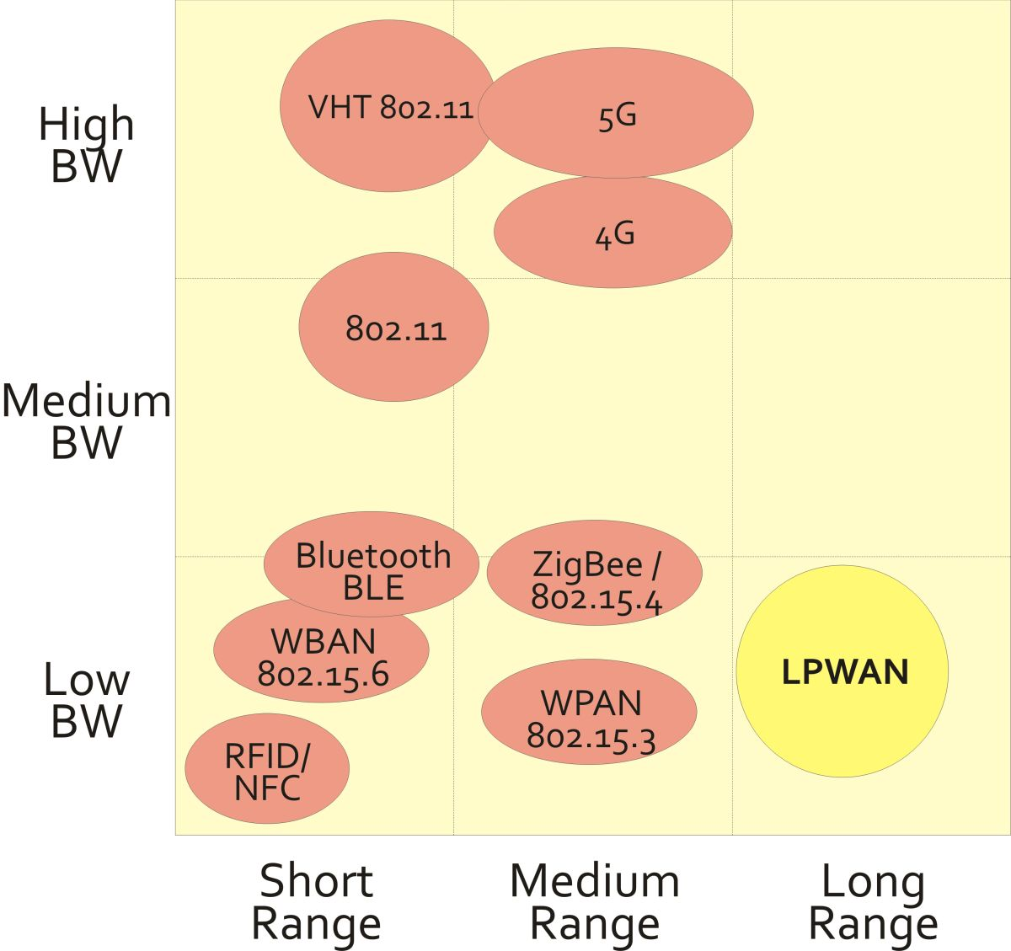

Figure 1. LPWANs frequency bands and range

Sigfox, LoRa and NB-IoT comparison
In the practical implementation of IoT systems, depending on the specific implementation (urban / rural environment, number of nodes, number and size of messages during the day, etc.), several types of LPWANs are used, [3-5].
Table 1 presents a comparison of the characteristics of the some conventional and some LPWAN networks.

TABLE 1
Conventional & LP networks characteristics comaprison

 | SIGFOX | NB-IoT | LoRa WAN | WiFi | ZigBee
Standard | Sigfox | 3GPP | LoRa Alliance | IEEE 802.11 | IEEE 802.15.4
Modulat. | BPSK | QPSK | CSS | DSSS, OFDM | DSSS, QPSK
Freq. | 433 MHz, 868 MHz, 915 MHz | Licensed (LTE) | 433 MHz, 868 MHz, 915 MHz | 2.4 GHz,  5 GHz | 868MHz 2.4 GHz
Coverage | 10 - 40 km | 2 - 20 km | 1 – 10 km | 10–100 m | 10–100 m
BW | 100 Hz | 200 kHz | 125 kHz, 250 kHz | 20/40/80/160 MHz | 2 MHz
TX Limit | 140 packets / day | Unlim. | Duty Cicle Lim. | Unlim. | Unlim.
Max Data Rate | 100 bps | 200 kbps | 50 kbps | 250kbps @ 2.4 GHz | 250kbps @ 2.4 GHz
Private Depl. | No | No | Yes | Yes | Yes
Energy Consum. | Low | Low | Low | High | Low
Security | Low | High | High | Low-High | High
- Sigfox technical overview
Sigfox is an LPWAN network and end to-end IoT connectivity solution based on its patented technologies. Sigfox network consists of base stations equipped with cognitive SDR connected to supporting servers via IP. The network nodes are connected to base stations using binary phase-shift keying (BPSK) modulation in an ultra-narrow band (100 Hz) subGHZ ISM band. By using the UNB, Sigfox is characterized with very low power consumption, high receiver sensitivity, and low-cost antenna design at the expense of ma throughput of only 100 bps and in practical implementations the number of uplink messages is limited to 140 msg/day and the max payload length is 12 bytes.
Without the acknowledgments support, the uplink communication reliability is ensured using time and frequency diversity and transmission duplication. Each end-device message is transmitted multiple times (three by default) over different frequency channels. As the base stations can receive messages simultaneously over all channels, the end device can randomly choose a frequency channel to transmit their messages. This simplifies the end device design and reduces its cost.

- LoRa technical overview
LoRa is a physical layer technology that modulates the signals in subGHZ ISM band using a proprietary spread spectrum technique (CSS - Chirp Spread Spectrum).
LoRa and other technologies operating in a narrow frequency band must be extremely energy efficient, and to maintain this, LoRaWAN uses a simple channel management strategy, so that the end nodes and the network itself can be energy efficient. LoRaWAN uses pure Aloha MAC protocol with additional confirmation mechanism. The LoRaWAN MAC level defines one mandatory and two optional classes of operation to cover all possible working scenarios, which are presented in Fig. 2, [6].

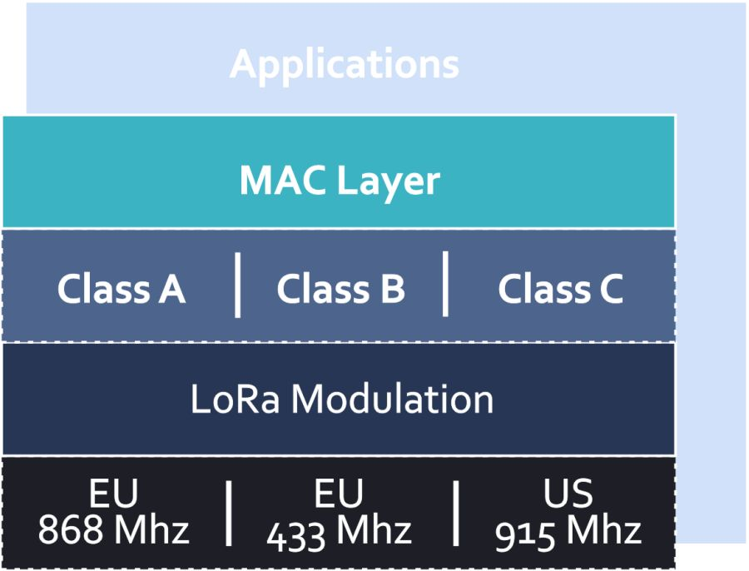

Figure 2. LoRaWAN classes

LoRaWAN has three main channel access strategies, presented as Class A, B and C.
Class A is an obligatory class for all network nodes and the incoming link (link to the node: downlink - DL) is controlled by the node itself. With this approach, each message sent by the node to the gateway activates two incoming windows through which the gateway can send data to the node, otherways, the gateway has to wait for information from the node to send new data to it.
In Class B, the nodes open DL windows at a specified time interval and only then the node can receive incoming packets.
Class C devices are the least energy efficient because they are always open to receiving traffic.
Table 2 shows the LoRaWAN classes comparison.

TABLE 2
The LoRaWAN classes comparison

CLASS | BATTERY CONSUMPTION | DESCRIPTION
A | Most energy efficient | Must be supported by all end-nodes. DL after TX
B | Efficient with controlled DL | Slotted communication sync. with beacon frames
C | Least efficient | Devices listen continuosly. DL without latency.

- NB-IoT technical overview
NB-IoT is a Narrow Band IoT technology which can coexist with GSM and LTE under licensed frequency bands. NB-IoT occupies a frequency band width of 200 KHz, which is the same size with the one resource block in GSM and LTE transmission. Here, the following operation modes are possible:
- Stand-alone operation: a possible scenario is the utilization of GSM freq. bands currently used.
- Guard-band operation: utilizing the unused resource blocks within an LTE carrier’s guard band.
- In-band operation: utilizing resource blocks within an LTE carrier.

The NB-IoT communication reduces LTE protocol functionalities to the minimum required for IoT applications. It is optimized to small and infrequent data messages and avoids the features not required for the IoT purpose, e.g., monitor the channel quality, carrier aggregation, and dual connectivity. Therefore, the netwotk nodes are energy and cost efficient. NB-IoT supports of up to 100K nodes per cell with the potential for scaling up the capacity by adding more NBIoT carriers. NB-IoT uses the single-carrier frequency division multiple access (FDMA) in the uplink and orthogonal FDMA (OFDMA) in the downlink, and use the quadrature phase-shift keying modulation (QPSK). The data rates are up to 200 kbps (downlink) and up to 20 kbps (uplink). The maximum payload size for each message is 1600 bytes.

LPWANs comparison in terms of IoT
Many factors should be considered when choosing the appropriate LPWAN technology for an IoT application including quality of service, battery life, latency, scalability, payload length, coverage, range, deployment, and cost. In the Fig. 3, Sigfox, LoRa and NB-IoT are compared in terms of these factors and their technical differences, [4].

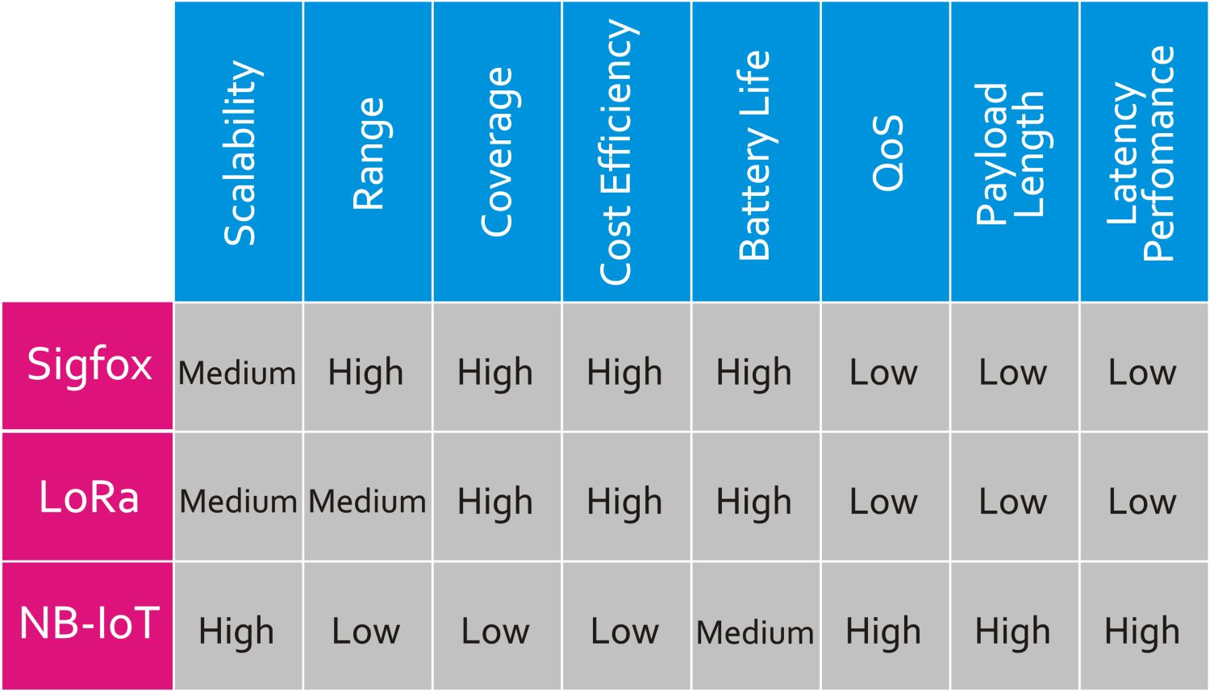

Figure 3. Sigfox, LoRa and NB-IoT comparison
i) QoS - Quality of Service
Sigfox and LoRa are asynchronous communication protocols which use unlicensed spectrum. They cannot offer the same QoS provided by NB-IoT which use a licensed spectrum and an LTE-based synchronous protocol, which are optimal for QoS at the expense of cost. So, from QoS aspect, NB-IoT is preferred for applications that require guaranteed QoS and applications that do not have this constraint should choose LoRa or Sigfox.

ii) Battery Life & Latency
In Sigfox, LoRa, and NB-IoT, end devices (nodes) are in sleep mode most of the time, which made them highly energy efficient.
The NB-IoT nodes consumes additional energy because of synchronous communication and QoS handling, and its OFDM/FDMA access modes require more peak current, and it can be said that the Lora/Sigfox LPWANs is more energy efficient. LoRa has class C which also handle low bidirectional latency at the expense of increased energy consumption. As conclusion, for applications with small data exchange and that the latency is not a priority, Sigfox and class-A LoRa are the best options. For applications that require low latency, NB-IoT and class-C LoRa are the better choices.

iii) Network coverage & range
The Sigfox major utilization advantage is that an whole city can be covered with single base, LoRa has a lower range (i.e., range <20km) that requires, for example, three base stations to cover an entire city like Skopje. NB-IoT has the lowest range and coverage capabilities (i.e., range <10km). and the deployment of NB-IoT is limited to LTE base stations.

LPWANs regulative

Radio spectrum limitations
Although theoretically the radio spectrum is an unlimited resource, in terms of wireless telecommunications and wireless signal transmission there are two main limiting factors:
a) The limitation in the low frequencies, comes from the Shannon-Hartley theorem, shown in equation (1), which relates the amount of information potentially transmitted over a channel.
$C=B{\text{log}}_{2}\left(1+\frac{S}{N}\right)$ (1)
where C is the channel traffic capacity (in bps), B is the channel bandwidth (in Hz) and S⁄N is the channel signal to noise ratio. So, to transmit an amount of information in a time period, either we have to use enough bandwidth or we have enough S/N ratio. In this trade-off there is a limited ability to increase the signal to noise ratio and it is easier to select the carrier frequencies that will provide enough bandwidth to allow the required traffic capacity.
b) The frequencies above PHz are known as ionizing radiation and harmful to human life, so they are avoided.
There are also other limitations - free space path loss (FSPL), earth curvature, etc. and the above facts it can be said that, in terms of telecommunications, the radio spectrum is a limited resource and therefore countries and international regulators have adopted several rules and restrictions in order to use it effectively.

Radio spectrum and IoT
IoT is based on the idea of a large number of connected devices and it is generally assumed that wired networks will be part of the infrastructure, but most of the connections will be wireless in order to reduce the cost of infrastructure and that the wireless networks allow mobility, [7].
In such wireless infrastructure, one of the main concerns is the power supply of wireless devices. There are four strategies to power IoT devices (network nodes):
a) direct connection to the power grid
b) rechargeable battery power
c) energy scavenging
d) life-long batteries.

The chosen energy strategy has a big impact on the communication capabilities of IoT devices, e.g. the more power is available, the more bandwidth the device can use.
There are currently several available wireless technologies with different properties which will determine the network behavior: latency, mobility, cost, capacity, power consumption, complexity, reliability, interference immunity, symmetrical uplink and downlink channels, etc.
According to ETSI classification, there are four main groups:
Cellular based: cellular technologies optimized for IoT: LTE-CATM, NBIoT and E-GSM. All this technologies take advantage of the licensed band.
Dedicated Star Networks: optimized for IoT technologies which network typology is a star and are built over shared spectrum: Sigfox, LoRaWAN, Weightless, Telensa, etc.
Dedicated Mesh Network: mesh networks covering wide area with multi-hops connectivity. These systems are also known as Network-Based SRDs.
Low power versions of LANs & PANs: WiFi, Bluetooth (5.0/4.2/4.1/4.0, Low Energy), WiGig, Ingenu, ZigBee, Thread, Z-wave, EnOcean, etc. They are also operate on ISM freq. bandwidth but the coverage range is much shorter than the dedicated star networks.

The first two subgroups (Cellular and dedicated star networks) are known as LPWAN. These two types of radio techniques share the common use of high sensitivity for increased radio coverage and the low power consumption. The term IoT-LTN (IoT - Low Throughput Network) refers to the Dedicated Star Networks category, which, in addition to the characteristics of LPWAN, adds the properties of shared spectrum, random channelization, star topology and half duplex communication.

C. LPWANs regulation technical constrains
With spectrum management regulators force spectrum maximum utilization and aim to foster economic activity around the use of the radio spectrum. The regulator selects the appropriate incentives that encourage the investitors to invest their resources to create new business opportunities and paradigm. For unlicensed bands, [8], the main task of the regulations is, in addition to the spectrum efficient use, to regulate its use in a way that will allow access to as many services as possible without mutual congestion and interference. Therefore, regulators select some technical parameters of radio transmission and decide some arbitrary thresholds following reasoned criteria. The first decision of the regulator is to select the frequency bands and corresponding applications. Higher frequencies are usually used for high throughput networks, lower frequencies are used for longer range communications (based on transmission power and distance correlation).
For a given band, the regulators usually establish a maximum Tx power limit, which results in determining a maximum coverage radius. Table 3 shows some of the important values affecting the regulations for the higher frequencies of the unlicensed bands in main world markets.

TABLE 3
Regulation technical constrains

 | US | Europe | China
Frequency Range (MHz) | 902-928 | 863-875.6 | 779-787
Maximum TX Power (dBm) | 30 (>50 ch.)  24 otherwise | 27 (869.4-869.6)  14 otherwise | 10
Minimum Number of Hopping Channels | 50 (BW2 < 250 kHz)  25 otherwise | - | -
Maximum Bandwidth of Hopping Channels (kHz) | 500 | - | -
Maximum Spurious Emission Threshold. (dBuV/m@3m) | 54 | 66 | 66
Parameters for Medium Access based on Duty Cycle
Band Duty Cycle (%) | - | 0.1 (863-868) 1 (865-868) 0.1 (868.7-869.2) 10 (869.4-869.6) 1 (870-875.6) | -
Band Duty Cycle Period (s) | - | 3600 | -
Channel Duty Cycle (%) | 2 (BW2 < 250 kHz) 4 (250 kHz < BW2 < 500 kHz) | - | -
Channel Duty Cycle Period (s) | Period (s) 20 (BW2 < 250 kHz) 10 (250 Hz < BW2 < 500 kHz) | - | -

IoT & LPWAN PRACTICAL APPLICATIONS

IoT applications overview
With the emergence of the Internet of Things (IoT), massive growth in the network node deployment is expected and the estimations are that there will be more than 75 billion IoT device connections by 2025, [9]. (connected cars, medical devices, sensors, point-of-sale terminals, wearables, etc).
The exponential growth in IoT is impacting virtually all human life aspects – business, industry, medicine, entertainment, human science and redefining the ways of designing, managing, and maintaining connections, networks, data, cloud apps and all other inter-connected technologies like artificial intelligence, machine learning, data analytics, blockchain etc.
With the great progress in the fields of electronics, communication, computing, sensing, actuating, and battery technologies, now it is possible to design highly power efficient LPWANs with many years of battery life and tens of kilometers of coverage which can be deployed for a broad range of smart and intelligent applications, including environment monitoring, smart cities, smart utilities, agriculture, healthcare, industrial automation, asset tracking, logistics and transportation, and many more, [10].
Some examples of the possible applications of LPWAN and IoT are:
Smart Cities: Smart parking, air and water quality measurement, sound noise level measurement, traffic congestion and traffic light control, trash collection optimization and waste management, utility meters, fire detection, environment management etc
Smart Environment: Water quality, air pollution reduction, climate temperature rise reduction, forest fire, landslide, animal tracking, snow level monitoring, and earthquake early detection
Smart Metering: Smart electricity meters, gas meters, water flow meters, gas pipeline monitoring, and warehouse monitoring
Smart Grid and Energy: Network control, load balancing, remote monitoring and measurement, transformer health monitoring, and windmills/solar power installation monitoring
Retail: Supply chain control, intelligent shopping applications, smart shelves, and smart product management
Automotives and Logistics: Insurance, security and tracking, lease, rental, share car management, quality of shipment conditions, item location, storage incompatibility detection, fleet tracking, smart trains, and mobility as a service
Industrial Automation: M2M applications, robotics, indoor air quality, temperature monitoring, production line monitoring, ozone presence, indoor localization of assets, vehicle auto-diagnosis, machine health monitoring, preventive maintenance, energy management, machine/equipment as a service, and factory as a service
Smart Agriculture and Farming: Temperature, humidity, and alkalinity measurement, wine quality enhancement, smart greenhouses, agricultural automation and robotics, meteorological station network, compost, hydroponics, offspring care, livestock monitoring and tracking, and toxic gas levels
Smart Homes: Energy and water use, temperature, humidity, fire/smoke detection, remote control of appliances, intrusion detection systems, art, goods preservation, and space as a service
eHealth: Patient health and parameters, connected medical environments, healthcare wearable, patients surveillance, ultraviolet radiation monitoring, telemedicine, fall detection, assisted living, medical fridges, sportsmen care, tracking chronic diseases, and tracking mosquito and other such insects’ population and growth

LPWANs technical characteristics for real life apps
The main features of LPWAN are the size of the area they cover, energy consumption and efficiency, the number of nodes they support, the cost of deployment, operation and maintenance, and depending on the specific application where the priority of each of these features should be applied, is different.
Also, depending on the type of applications, the ability to connect with other types of technology, support for communication protocols and data exchange, etc. is especially important.
Thus, there are specialized LPWANs that can be used for a small number of highly specialized applications, but there are also universal LPWANs that are designed to be applied to a wide range of applications in various fields.
IoT applications in which LPWANs are used can include measurement of environmental parameters with different accuracy and frequency of measurements (eg temperature, humidity, pollution with PM particles, CO, CO2, NO gases, noise measuring, etc.) and at the same time measuring the health parameters of the population and requesting a mutual correlation of the measured parameters and assessing the impact of environmental pollution on the health of the population.
Another application would be waste management, detection of the waste containers fullness and creation of optimal routes for garbage collection.
With smart parking applications, users always will have information on free parking spaces near the places where they want to park, will be able to reserve these parking spaces and thus reduce the time required for parking and pollution due to longer driving.
If the intended application is to be used in urban, densely populated areas, it is clear that the primary requirement of the deployed LPWANs will be support for a large number of network nodes, at the expense of energy efficiency and coverage, due to the greater availability of energy sources in urban areas and the smaller area to be covered.
Unlike this type of implementation, applications that would measure the parameters of the environment in large areas needs high energy efficiency and coverage, at the expense of transmission capacity and number of nodes, so in this case suitable networks are energy efficient LPWANs with high coverage ability.
In practice, mesh network configurations are common, due to the requirements for a large area coverage, with a large number of nodes and a large transmission capacity.
Table 4 provides the relevance of the major characteristics - coverage, capacity, cost, and low power operation to the different applications The relative scales for applicability of the characteristics to the application are high (H), medium (M), and low (L).

TABLE 4
Relevance of LPWANs characteristics to Applications

Applications | Cover. | Capacity | Cost | Low Power
Smart Cities | H | H | H | M
Smart Environment | M | H | H | H
Smart Metering | H | H | H | M
Smart Energy | H | H | M | M
Smart Agriculture and Farming | H | H | M | H
Smart Homes | H | M | L | L
eHealth | H | H | M | H

Conclusion
The paper describes the features and modulation techniques used in wireless communications, with a special description of the modulation used in LPWAN and on the basis of which these networks have the characteristics suitable for use in IoT - low energy consumption, support for a large nodes numbe, ability to cover large areas, integrated security, etc.
The frequency bands in which LPWANs operate and the possible problems and limitations in case of unregulated operation are described. Regulations and restrictions by states and state and international agencies and regulatory bodies for effective use of radio spectrum and uninterrupted communication are shown.
Based on the areas in which the IoT concept has a practical use, specific applications are presented, as well as the necessary features of LPWANs adapted to the specific implementations.
References
- Toni Janevski, “NGN Architectures, Protocols and Services”, Wiley, UK, 2014.
- “Technical and operational aspects of low-power wide-area networks for machine-type communication and the Internet of Things in frequency ranges harmonised for SRD operation”, Rep. ITU-R SM.2423-0, ITU, Geneva 2018.
- Brian Ray, “NB-IoT vs. LoRa vs. Sigfox”, Link Labs (https://www.link-labs.com/), 2018.
- Kais Mekki, Eddy Bajic, Frederic Chaxel, Fernand Meyer, “A comparative study of LPWAN technologies for large-scale IoT deployment”, Research Centre for Auto. Control of Nancy, 2018.
- U. Raza, P. Kulkarni, M. Sooriyabandara, “Low Power Wide Area Networks: An Overview”, IEEE Commun. Surv. Tutor, 19, 855–873, 2017.
- Ertürk M.A, Aydın M.A, Büyükakka M.T and Evirgen H, “A Survey on LoRaWAN Architecture, Protocol and Technologies”, Future Internet 11 (2019): 216.
- Dhaval Patel, “Low Power Wide Area Networks (LPWAN): Technology Review And Experimental Study on Mobility Effect,” South Dakota State University, 2018.
- David Castells-Rufas, Adrià Galin-Pons, Jordi Carrabina, “The Regulation of Unlicensed Sub-GHz bands: Are Stronger Restrictions Required for LPWAN-based IoT Success?”, Autonomous University of Barcelona, November 2018.
- https://www.statista.com/statistics/471264/iot-number-of-connected-devices-worldwide, accessed July 2021.
- Philip J. Basford, Florentin M. J. Bulot, Mihaela Apetroaie-Cristea, Simon J. Cox, Steven J. Ossont, “LoRaWAN for Smart City IoT Deployments: A Long Term Evaluation”, Sensors | An Open Access Journal from MDPI, Jan 2020.

